Identification de l’incident :

|  |  |  |  |
| --- | --- | --- | --- |
| **De :** | Philippe Reynaud |  |  |
| **Date** | 18/03/2020 | | |
| **Classification** | MAM : Optimize Cable validation | | |
| **Reproductible :** Yes | | | |
| **Version IE** : IE 11.1130.17134.0 | | | |
| **Version client 3D :** (Connexion au client 3D : touche shift+Ctrl+v) : VDC 5.6.4 20191024 | | | |

Steps to reproduce :

# PROBLEM:

When opening a device, user doesn’t know if he needs to go to the cable tab or not.

If there is no cable to check, he goes to Cables tab for nothing.

If there are cables to check and he forgot to do it, there is a Device validate popup before the Warning for cables validation

In addition, some requests that may help user by limit the number of clicks.

# Propositions :

## Number of cables at the device level

As discussed on Webex, we appreciate to have information about cables at the Device level.

Something like that :

|  |  |  |
| --- | --- | --- |
| Cables | Requested | Total |
| Power |  |  |
| Network |  |  |
| Fiber |  |  |
| Storage |  |  |

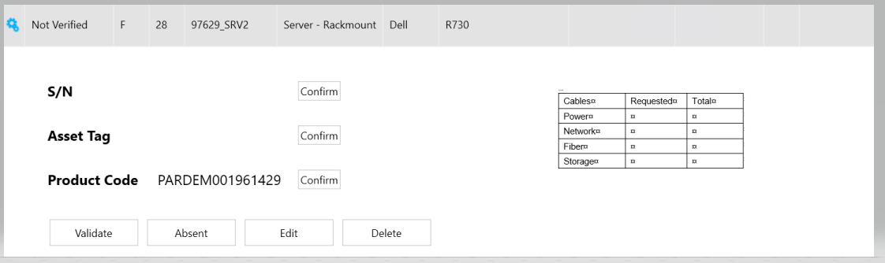

## Don’t raise device validation popup if there are still cables to check

User think he has finished the device, then he click on Validate button

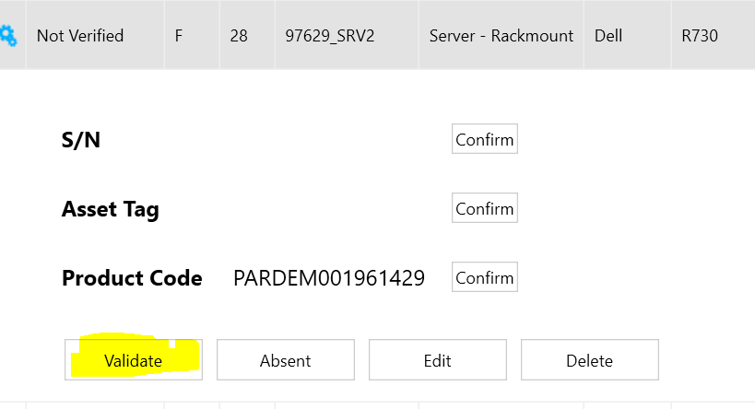

He confirm the validation

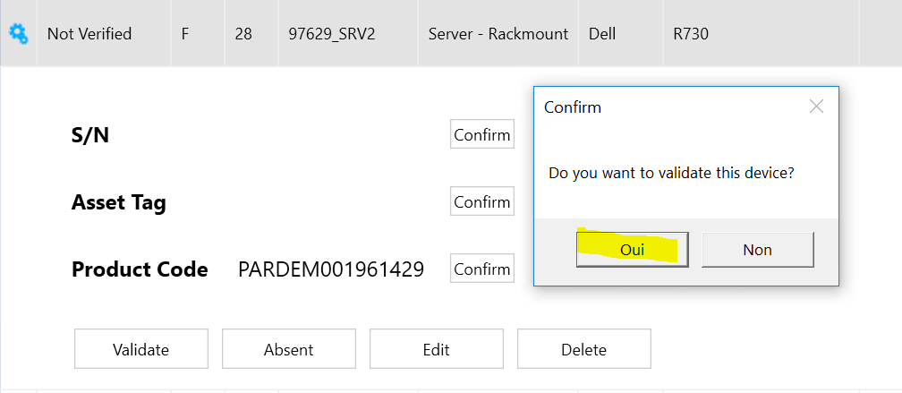

But there are cables to validate

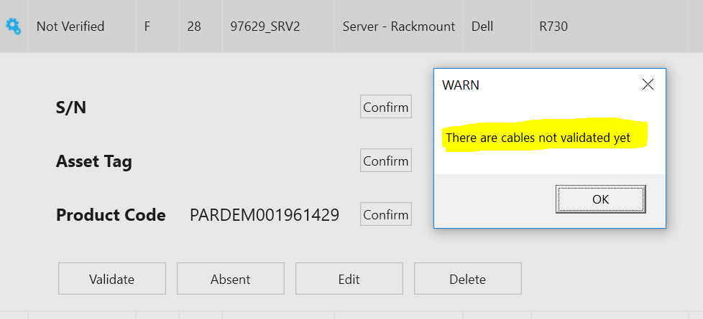

I think the cable popup should appears before the popup bellow.

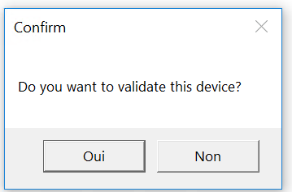

## Go to cables tab after Warning popup

When user clicks on “OK” button I think that Cables tab should open

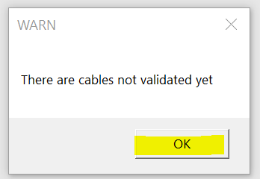

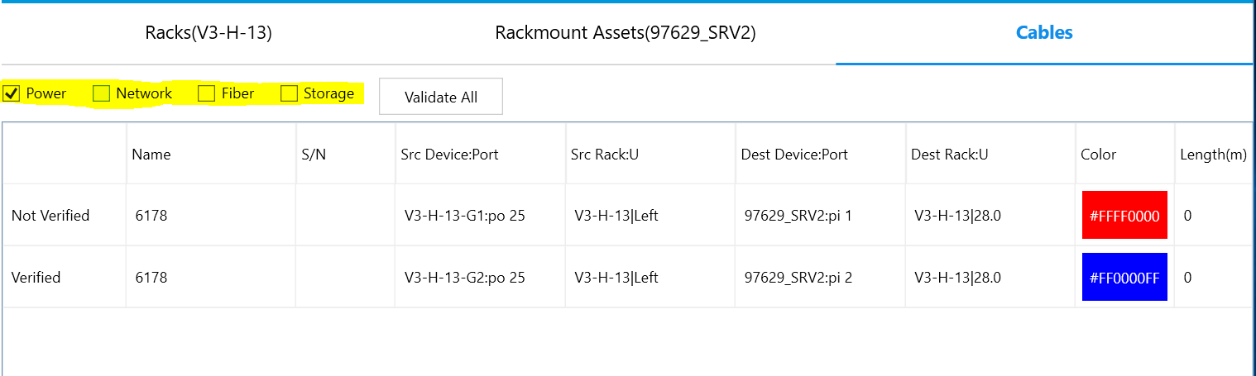

And only the requested cables should be displayed by default.

## Go back to Device when all the displayed cables are checked

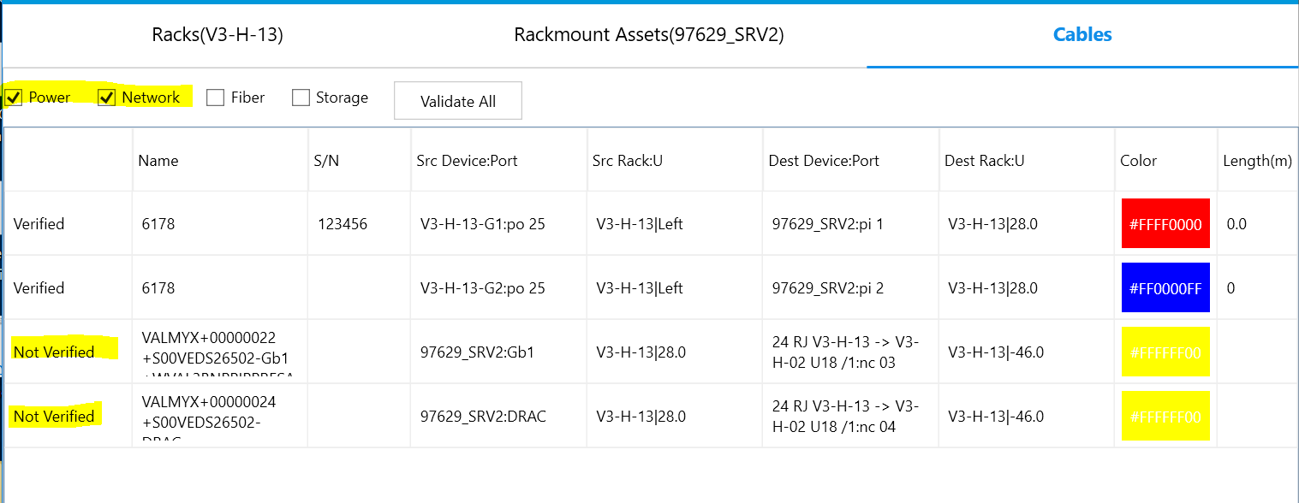

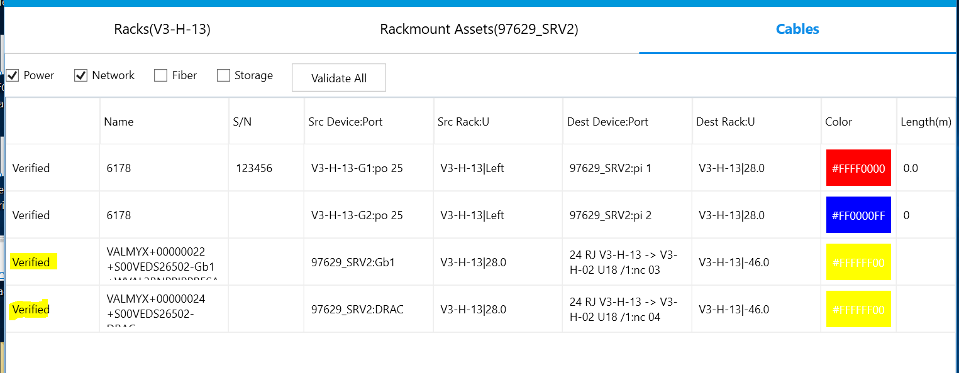

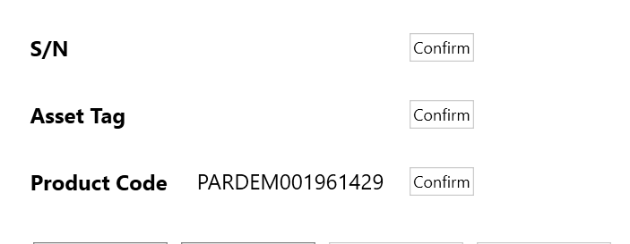

## Close the device when it’s validated

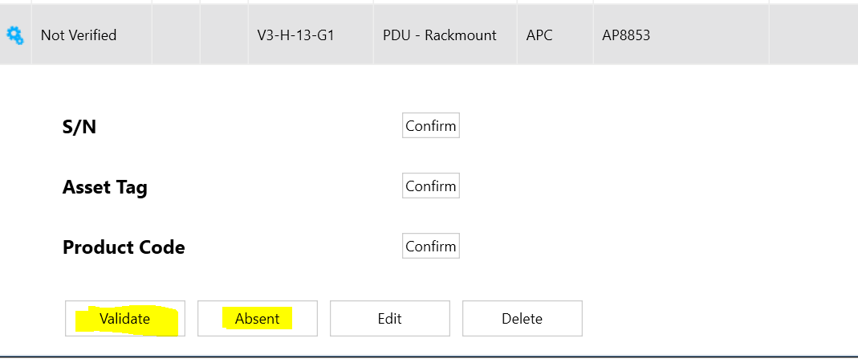



Or

